**PRODUCT 1**

**WEB ADDRESS:**

[***https://www.cngunited.com/***](https://www.cngunited.com/)

**COMPANY NAME:**

***CNG UNITED***

**PRODUCTS NAME:**

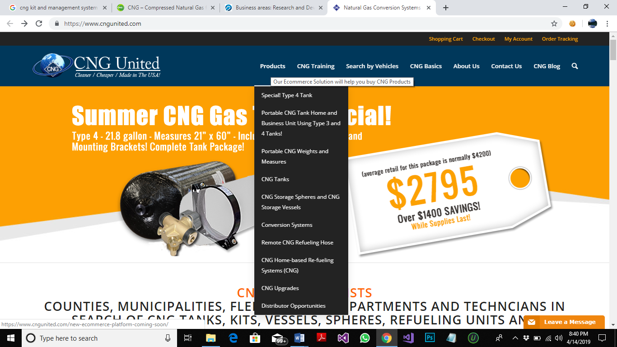

**FEATURES:**

1. SHOPPING CART
2. CHECK OUT SYSTEM
3. ORDER TRAKING SYSTEM
4. REGISTRATION OF CUSTOMERS
5. PRODUCT SUPPORT MESSAGE
6. SEARCH ENGINE
7. SEARCH BY VEHICLE
8. SEARCH OF CNG TANKS, KITS, VESSELS, SPHERES, REFUELING UNITS AND COUNTY WEIGHTS & MEASURE UNITS
9. PROVIDE INFORMATION WHICH LOCATION IN THE VEHICLE PART TO BE FITTED
10. PROVIDE INFORMATIVE VIDEOS
11. CNG BLOG NEWS AND STORIES

**INTERFACES:**

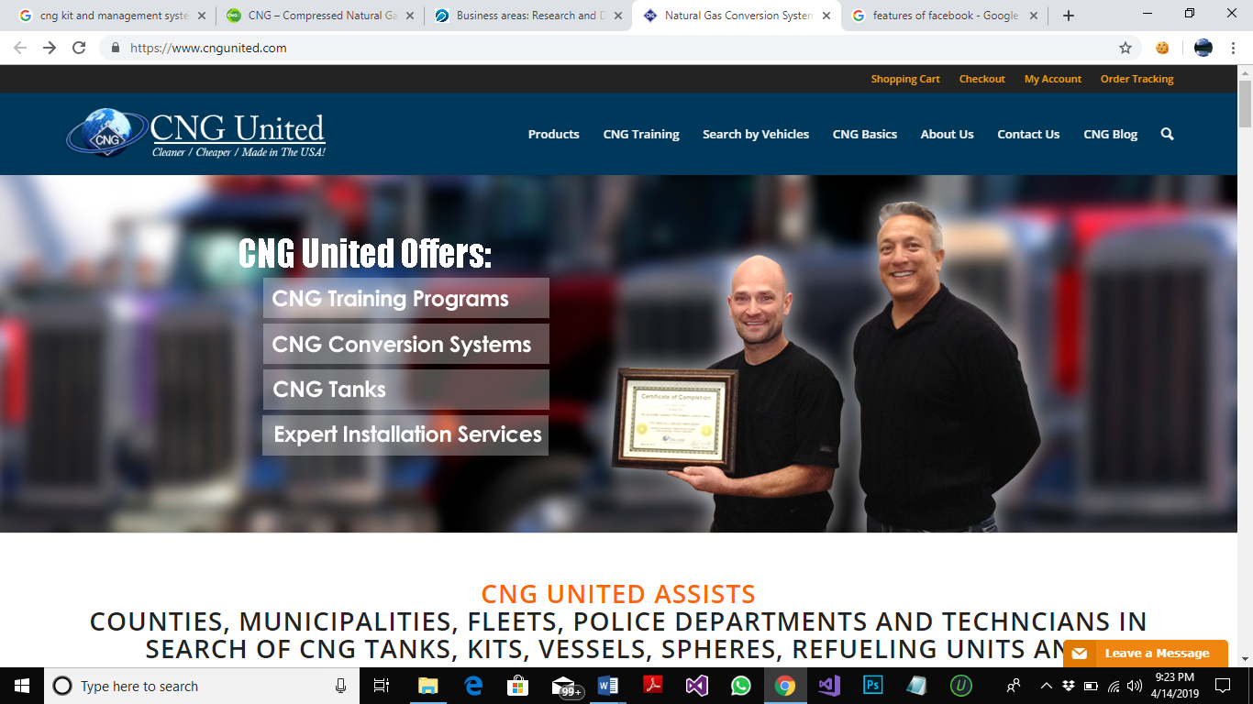

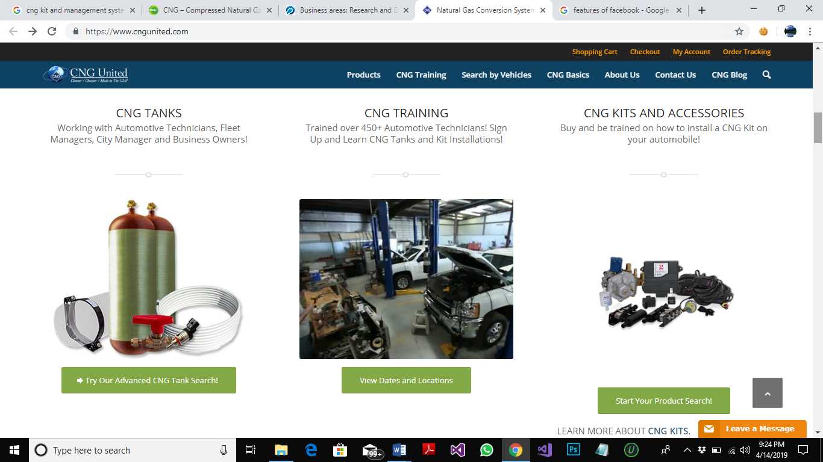

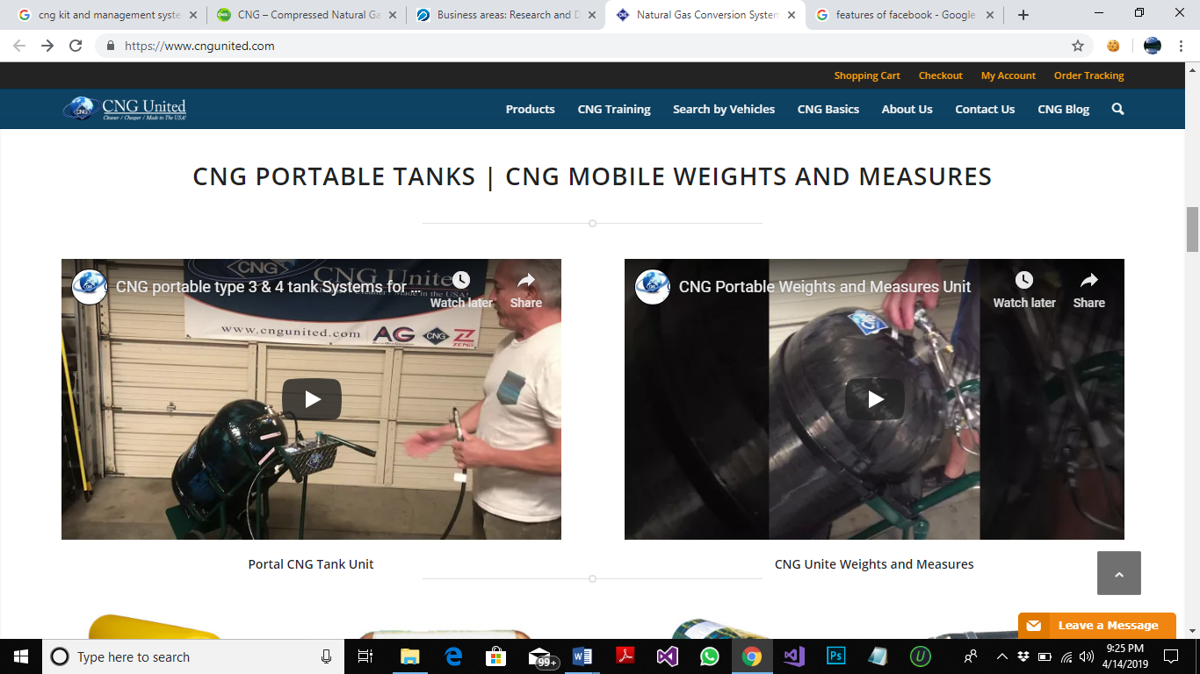

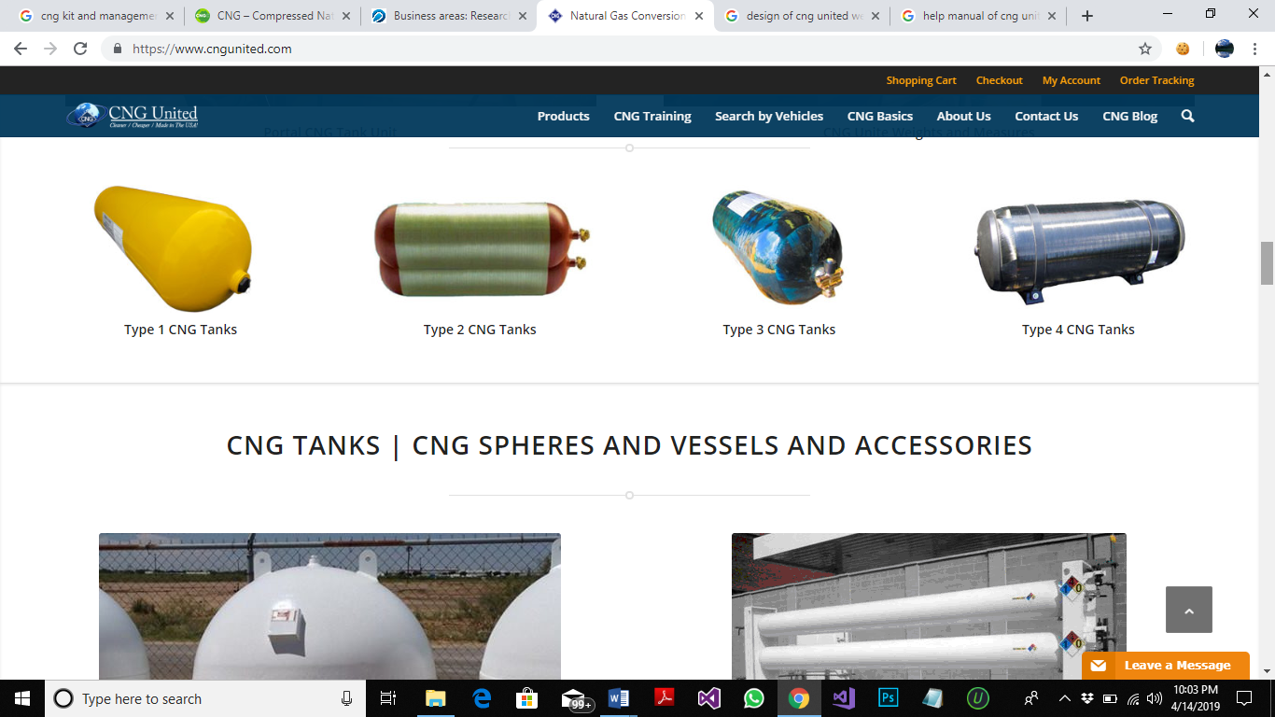

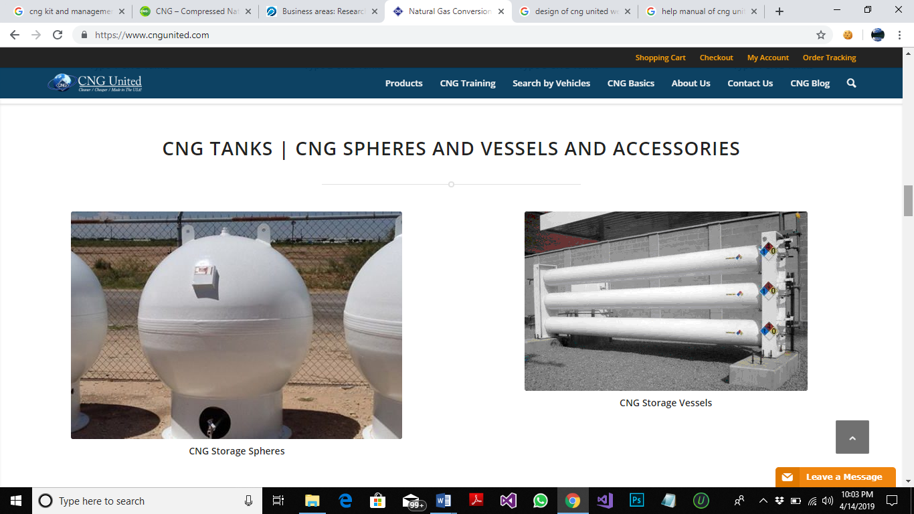

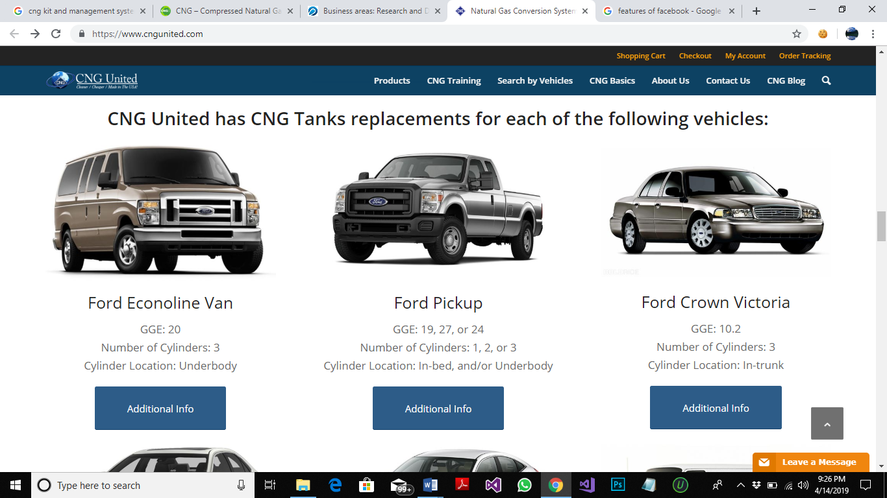

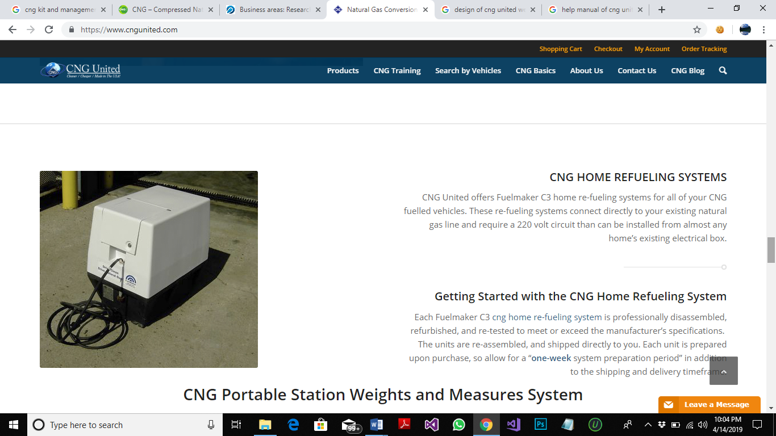

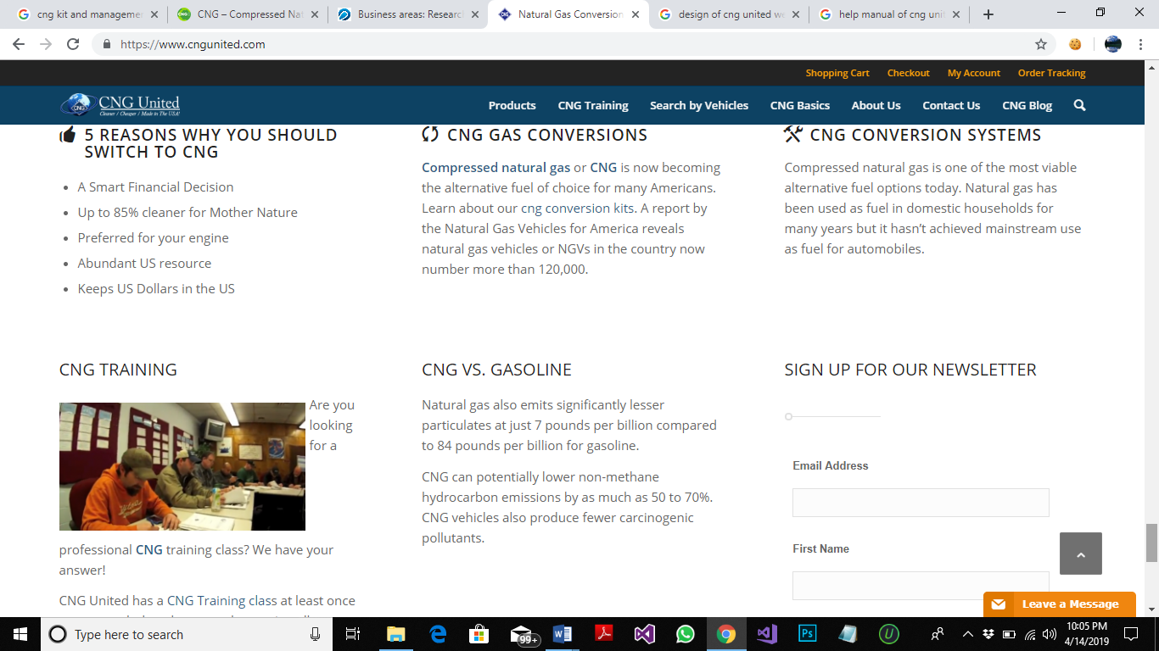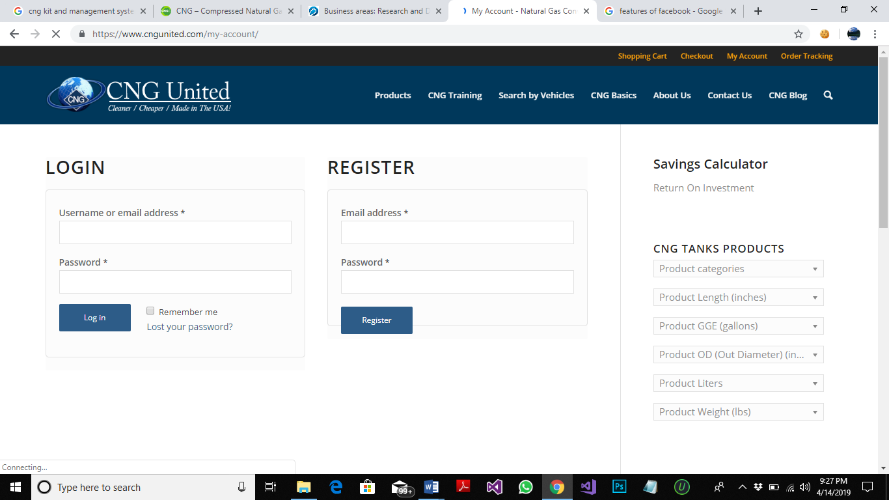

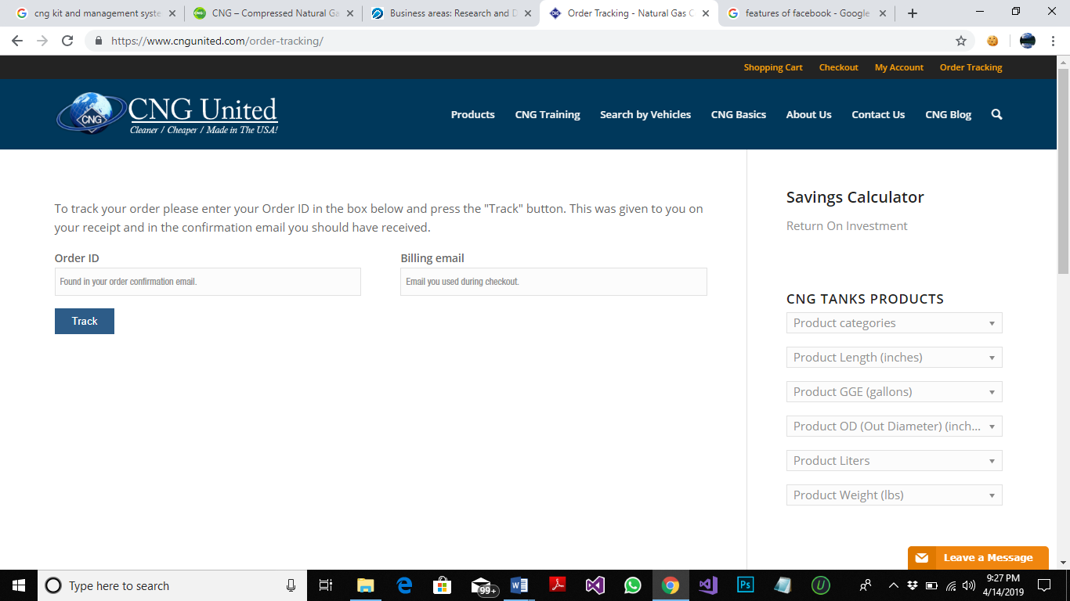

**COST:**

Not given

**DESIGN:**

DESIGN AND DEVELOPED BY **(Will2Design)**